j;, LTspice - ECA0404_C03 AT2_INPUT_192519090
File Edit Hierarchy View Simulate Tools Window Help

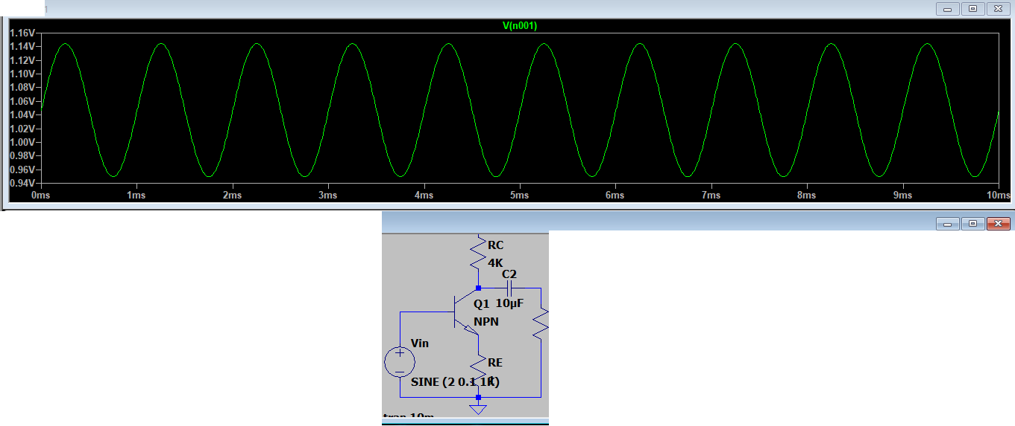
I:::: Draft1 -( ECA0404_CO3AT2_INPUT_192519090
I::::Dratt

-( ECA0404_C03AT2_INPUT_192519090

..2..

T
(5l X

RL

2K

Click to plot V(N001). DC operatinQ point: V(n001) = 1.0468741V

19' LTspice - ECA0404_C03 AT2_INPUT_192519090
File Edit Hierarchy View Simulate Tools Window Help
I:::: Draft1 -( ECA0404_CO3AT2_INPUT_192519090
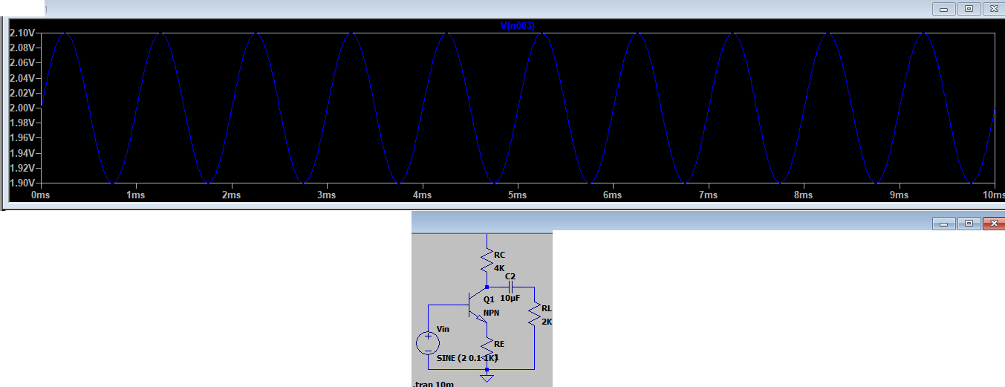
I::::Dratt

-( ECA0404_C03AT2_INPUT_192519090

..2..

T

(5l X

